INTRODUCTION

PROJECT TITLE: INSIGHT STREAM NAVIGATE FOR THE NEW LANDSCAPE

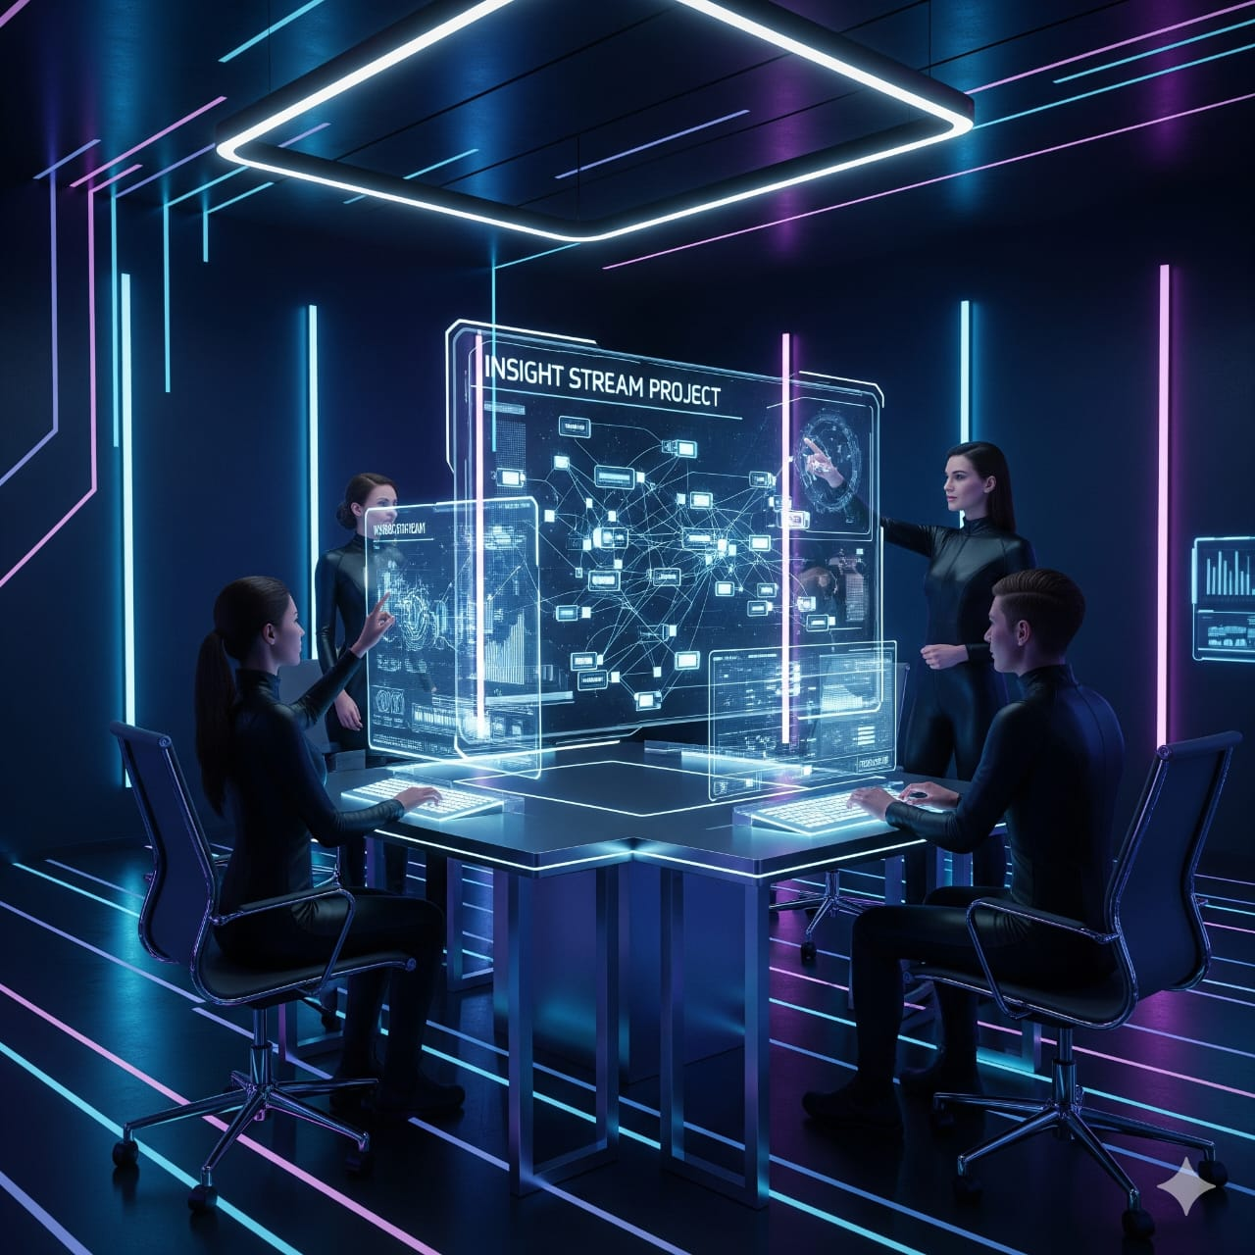

Team ID: NM2025TMID36528

**Team Leader:**

Janavikaa .D- 24cs035janavikaa@gmail.com

**Team Members:**

Ilakkiya . V- 24csilakkiya034@gmail.com

Jayashree .S- 24csjayashree036@gmail.com

Jayasri. S- 24csjayasri037@gmail.com

INSIGHT STREAM: NAVIGATE FOR THE NEWS LANDSCAPE

Navigate for the News Landscape" is a web application designed to revolutionize how users discover and consume news. The project focuses on providing an intuitive and dynamic platform that goes beyond traditional news consumption by catering to a wide range of user interests, from casual readers to seasoned professionals.

​**Project Goals and Purpose**

​The primary purpose of InsightStream is to deliver a streamlined and personalized news experience. It aims to solve the problem of information overload in the digital age by providing a platform that allows users to effortlessly navigate a vast amount of news content. Key goals include:

​**Redefine News Consumption**:

To create a new way for users to interact with news, moving beyond simple article aggregation to a more dynamic and engaging experience.

​**Enhance User Experience**:

To build an intuitive, user-friendly interface that simplifies the process of finding and consuming relevant news.

​**Personalize Content Delivery**:

To provide users with a customized news feed based on their interests and preferences, ensuring they get the stories that matter most to them.

​**Encourage Community and Engagement**:

To foster a community of news enthusiasts by providing features that encourage collaboration and sharing.

**Key Features**

​The application is built with a robust set of features to achieve its goals:

​**Dynamic News Feed**:

A central feature that provides real-time updates of the latest news articles from various sources.

​**Category-Based Filtering**:

Users can filter news by specific categories such as politics, sports, technology, and entertainment. This allows for focused browsing and exploration.

​**Search Functionality**:

A powerful search bar enables users to find specific news articles or topics using keywords.

​**Personalized Recommendations**:

The platform uses an intelligent system (potentially AI/ML-driven) to suggest articles and topics to users based on their browsing history and saved content.

​**Bookmarking**:

A convenient feature that allows users to save articles for later reading, creating a personal library of favorite content.

​**Responsive UI**:

The application is designed to be fully responsive, ensuring a seamless experience on both desktop and mobile devices.

​**Light/Dark Mode**:

Users can switch between a light and dark theme for enhanced visual comfort and a personalized browsing experience.

​**Architecture and Technology**

InsightStream is typically built as a modern web application, often utilizing a component-based architecture for a scalable and maintainable codebase.

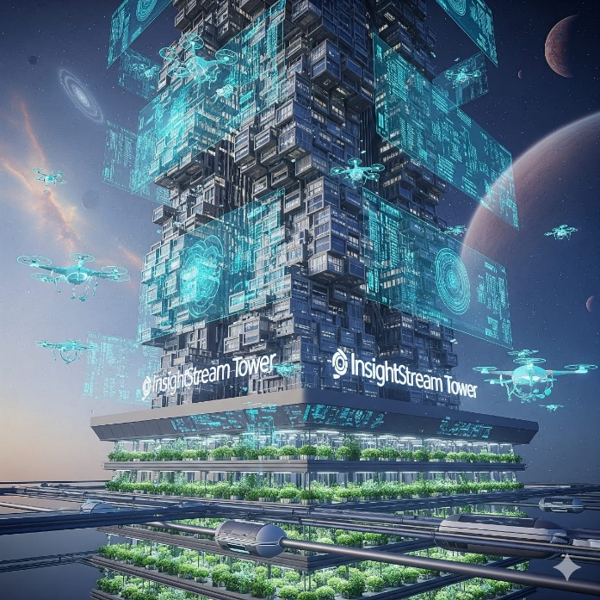

**Frontend**:

The user interface is developed using a JavaScript library or framework like React.js. This allows for a dynamic and interactive user experience.

​**State Management**:

State management is handled through a system like Context API (for smaller projects) or Redux (for larger, more complex projects) to manage global data, such as user preferences, bookmarks, and search results.

​**Routing**:

React Router is used to handle navigation between different pages, such as the home page, category pages, search results, and bookmark lists.

​**Styling**:

A CSS framework like Tailwind CSS is often used for a fast and efficient design process, enabling the creation of a modern and responsive user interface.

​**Data Source**:

The application fetches news data from external sources, likely through an API (e.g., NewsAPI). This is a crucial utility that allows for the real-time aggregation of articles.

​**Backend**:

A backend can be implemented to handle more complex functionalities such as user authentication, data processing, or personalized recommendations, possibly using technologies like Node.js and a database like Redis for real-time data handling.

**Set-up Instructions**

The "InsightStream" project is a web application that requires a specific environment to be set up. Follow these steps to get the project running locally on your machine.

* **Prerequisites**:

Before you begin, ensure you have Node.js and npm (Node Package Manager) installed. You can download the latest LTS (Long-Term Support) version of Node.js from the official website.

* **Clone the Repository**:

Use Git to clone the project repository from a hosting service like GitHub. Open your terminal or command prompt and run: git clone <repository-url>

* **Navigate to the Project Directory**:

Once the cloning is complete, change your current directory to the project folder: cd insightstream-news-app

* **Install Dependencies**:

The project relies on various libraries and frameworks. Install all the necessary packages by running the following command in the project's root directory: npm install

* **Create an Environment File**:

The application may require API keys for external services (like a news API). Create a file named .env in the root of your project and add the required variables. For example: REACT_APP_NEWS_API_KEY=your_api_key_here

**Core Programming Languages**

The "InsightStream" project is built using a modern technology stack that relies heavily on a few key languages:

* **JavaScript**:

The primary language for both the frontend and backend. It powers the interactive elements of the user interface and handles server-side logic.

* **HTML**:

Used for structuring the content and building the basic layout of the web pages.

* **CSS**:

A stylesheet language used to design and style the frontend, making it visually appealing and responsive.

**Development Tools & Concepts**

A number of tools and concepts are essential for developing and maintaining the project:

* **Node.js**:

A JavaScript runtime environment that allows you to run JavaScript code outside of a web browser. It's the foundation for the project's backend.

* **npm** (Node Package Manager):

Used to install, manage, and share code packages (dependencies) for the project.

* **API** (Application Programming Interface):

The project interacts with an external API (e.g., a news API) to fetch real-time news data.

* **React Router**:

A standard library for routing in React applications, enabling navigation between different pages without a full page reload.

* **Context API or Redux**:

Used for state management, which is the process of managing and sharing data that changes over time across different components of the application.

**Backend-Specific Prerequisites**

While the core project is focused on the frontend, some functionalities may require a backend. If a backend is included, these are the prerequisites:

* **Node.js Runtime**:

The backend server runs on Node.js.

* **Express.js** (Commonly):

A fast, unopinionated, minimalist web framework for Node.js, often used to build the backend API.

* **Database**:

Depending on the project's complexity, a database like MongoDB or Redis may be required to store user data, bookmarks, or other persistent information.

**Frontend-Specific Prerequisites**

The frontend is the user-facing part of the application. These are the main prerequisites for building the frontend:

* **React.js**:

A popular JavaScript library for building user interfaces. It's the core framework for the project's frontend.

* **CSS Framework** (e.g., Tailwind CSS):

A utility-first CSS framework for rapidly building custom user interfaces. It's often used to style the components.

**Integrated Development Environment (IDE)**

While you can use any text editor, an IDE provides a more streamlined development experience.

* **Visual Studio Code (VS Code)**:

This is the most recommended IDE for JavaScript projects. It offers powerful features like intelligent code completion, syntax highlighting, and integrated terminal. It can significantly boost your productivity.

**Folder Structure**

A well-organized folder structure is crucial for project maintainability. A typical structure for this project looks like this:

/insightstream-news-app

├── node_modules/

├── public/

│ ├── index.html

│ └── ...

├── src/

│ ├── assets/ (images, icons, etc.)

│ ├── components/ (reusable UI components like buttons, cards)

│ ├── pages/ (main page components like Home, Categories)

│ ├── App.js

│ ├── index.js

│ └── ...

├── .env

├── package.json

├── package-lock.json

└── README.md

* src: Contains all the source code for the application.

* components: Holds the reusable, smaller UI parts (e.g., Header.js, NewsCard.js).

* pages: Contains the main page components that are rendered by the router (e.g., HomePage.js, BookmarksPage.js).

* assets: Stores static files like images and fonts.

* .env: Stores environment variables.

* package.json: Lists all project dependencies and scripts.

**Running the Application**

After completing the setup and installing dependencies, you can run the application.

* Open a new terminal in the project's root directory.

* Run the command: npm start

* This command will start a local development server. The application will typically open in your default web browser at http://localhost:3000. If it doesn't open automatically, you can navigate to this URL manually. The server will also automatically reload the page whenever you make changes to the source code.

🔹 1. Landing Page (Homepage)

Header / Navbar:

Search bar to quickly find articles.

Featured News Section:

Top trending headlines with images.

Carousel / slider for breaking news.

Category Highlights:

Grid of categories (Politics, Sports, Tech, Entertainment, etc.).

**Footer:**

Links to About, Privacy Policy, Terms, Social Media.

🔹 2. User Dashboard (After Login)

Top Bar: User profile pic, notifications, search.

Sidebar Navigation: Home, Categories, Bookmarks, Saved Articles, Settings.

**Main Area:**

Personalized news feed (based on user’s chosen categories).

Filter/Sort (Latest, Trending, Most Read).

Bookmark / Save buttons on each article.

Right Sidebar (Optional):

Quick stats (No. of saved articles, categories followed).

Suggested content / trending topics.

🔹 3. News Details Page

Full article view.

Title, image, author/source, publish date.

Social share buttons (Facebook, Twitter, WhatsApp).

“Save for later” / “Bookmark” option.

Related articles section.

🔹 4. Admin Panel (For Moderators/Admins)

**Dashboard Overview:**

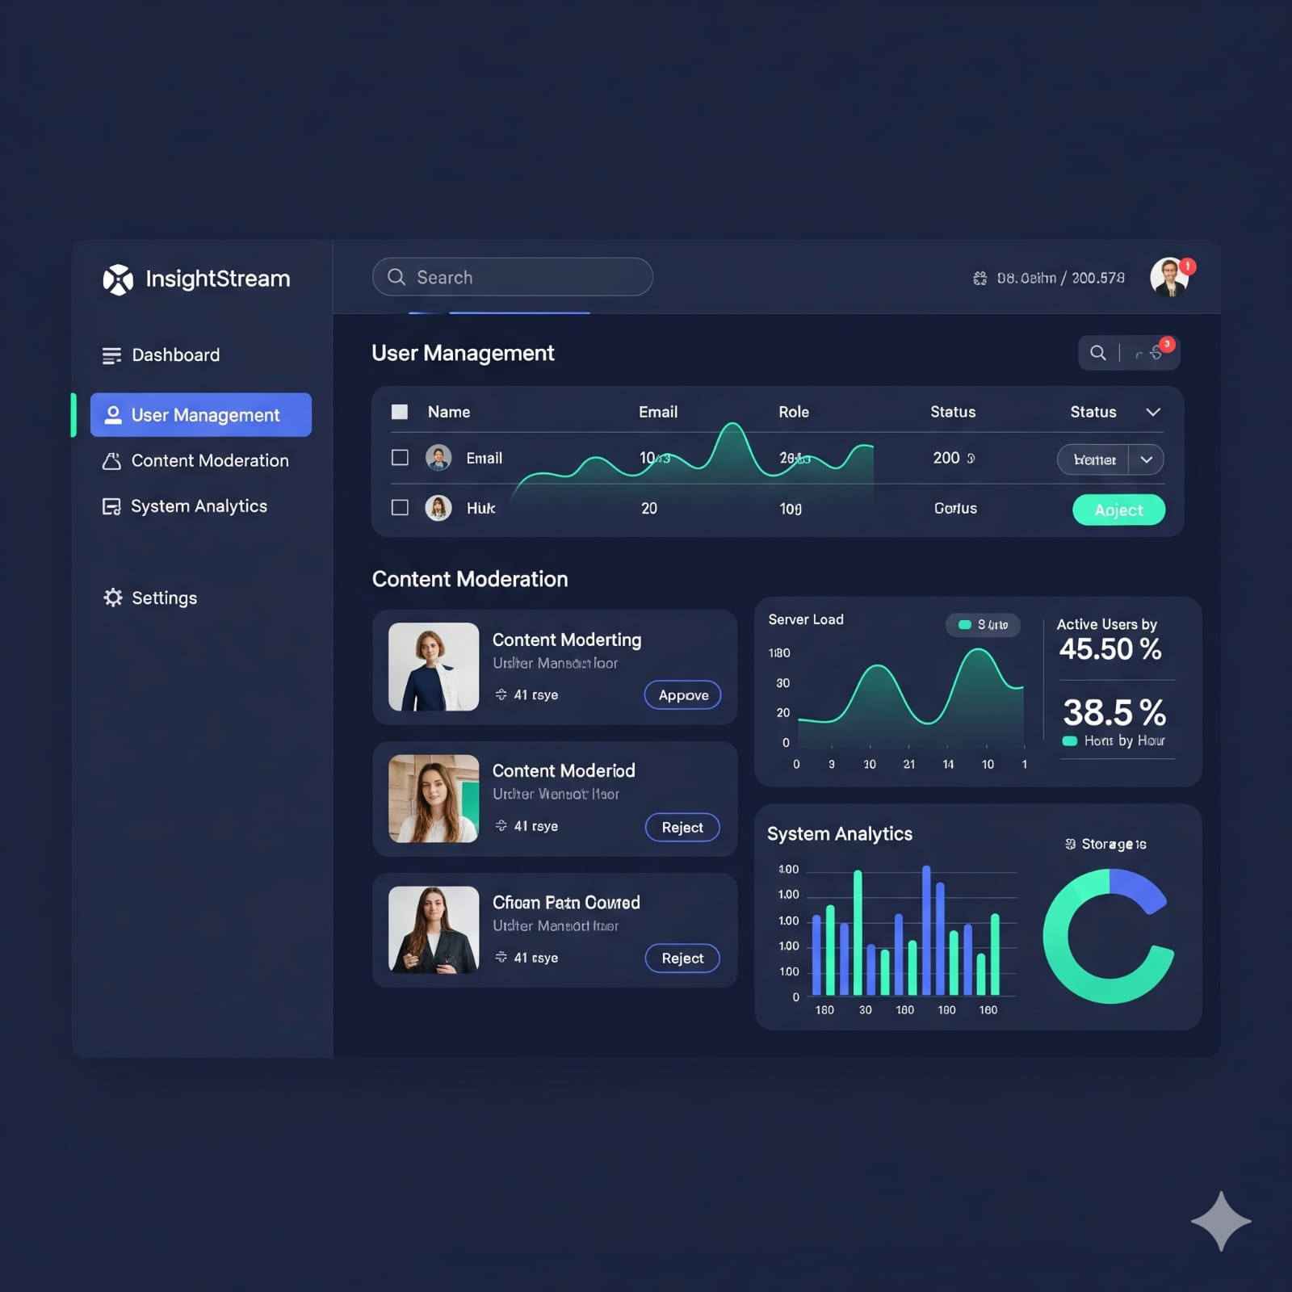

Total users, total articles, trending categories, recent activity.

Sidebar Navigation: Users, News, Categories, Analytics, Settings.

**Main Sections:**

User Management (view, edit, block users).

News Management (approve, edit, delete, feature news).

Analytics (charts showing article views, user activity).

🔹 5. Common UI Elements

Buttons: Rounded, soft shadows, hover effects.

Cards: For each article (image + title + short description).

Search Bar: With category filter dropdown.

Dark/Light Mode Toggle: Improves accessibility.

Responsive Design: Works smoothly on mobile, tablet, desktop.

🔹 6. Tools/Libraries for UI (if built in React)

Tailwind CSS or Material-UI / Shadcn UI → For modern, clean design.

Lucide Icons / FontAwesome → For category icons.

Recharts → For analytics/insight graphs in Admin Panel.

Framer Motion → For animations (smooth transitions, hover effects).

**Comparison with Existing Solutions**

**Interpretation 1**: InsightStream as a News Aggregation Platform

This project is described as a news aggregation platform that uses AI and machine learning to provide users with a personalized, real-time news feed. It aims to solve the problem of information overload and misinformation.

* Google News:

A highly established news aggregator with a broad range of sources and robust personalization. Google News has a massive data set and a long history of refining its algorithms.

* Feedly:

A popular RSS reader and news aggregator. Its strength is in allowing users to follow specific sources and topics, giving them more granular control than a purely algorithmic feed.

* Flipboard:

Known for its magazine-style, visually appealing interface. It offers a curated experience but may be less focused on real-time updates and deep personalization based on a user's specific behavior.

**Interpretation 2**: InsightStream as a Marketing Analytics Platform

This project is described as a tool for marketing professionals to get real-time consumer insights. It's designed to accelerate decision-making by transforming complex data into easy-to-understand visualizations.

* Google Analytics:

The industry standard for website traffic and user behavior analysis. Its strength is its comprehensive data collection and integration with other Google services.

Adobe Analytics:

A powerful enterprise-level analytics solution known for its deep customization and ability to handle large, complex datasets.

* Tableau/Power BI:

These are business intelligence tools that specialize in data visualization. They are not real-time data sources themselves but are used to create dashboards from various data feeds.

**Testing Levels**

1. Unit Testing

Used to test small, individual components (like a button, API call, or function).

Jest

Most popular testing framework for JavaScript & React.

Tests React components, functions, and APIs.

Example: test if “NewsCard” displays title correctly.

Mocha + Chai

Flexible testing framework with assertion libraries.

Works well for Node.js backend tests (e.g., API routes).

1. Integration Testing

Used to check how multiple components or modules work together.

React Testing Library (RTL)

Works with Jest to test UI interaction.

Example: test if clicking on a category filter updates the news feed.

Supertest

Tests Node.js/Express APIs.

Example: ensure /api/news returns a list of articles.

1. End-to-End (E2E) Testing

Used to test the entire flow (like a real user).

Cypress

Modern, fast, and widely used for web app E2E testing.

Example: test login → dashboard → saving an article → logout.

Selenium / WebDriverIO

Automates browsers for cross-browser testing.

Example: test if InsightStream works in Chrome, Firefox, and Edge.

Playwright

Newer alternative to Selenium, supports multiple browsers and mobile emulation.

Simulates multiple users visiting your site.

Example: test if InsightStream handles 10,000 users at once.

Locust (Python-based)

Load testing tool to measure API and backend performance.

Lighthouse (Google)

Tests performance, SEO, accessibility, and best practices.

1. Security Testing

Protect users and data.

OWASP ZAP

Finds security vulnerabilities (SQL injection, XSS, etc.).

Burp Suite

Tests API security and web vulnerabilities.

5. Automation & CI/CD Testing

Used for continuous integration, so every code push is tested.

GitHub Actions / GitLab CI / Jenkins

Runs tests automatically on every commit.

Example: When a developer adds a new news API, tests run to check everything still works.

**About the InsightStream Project**

The InsightStream project is a modern web-based application designed to deliver news and insights from various categories in one streamlined platform. It allows users to access information on topics such as politics, sports, technology, business, health, and entertainment in an organized and visually appealing manner.

Developed using React, HTML, CSS, and JavaScript, InsightStream ensures a smooth user experience with fast loading, responsive design, and interactive features. The platform focuses on providing:

**Categorized News Feeds** – News divided into multiple sections for easy browsing.

**User-Friendly Interface** – Clean design for quick navigation and readability.

**Real-Time Updates** – Access to the latest news and insights as they happen.

**Engagement & Accessibility** – Designed to keep users informed in an interactive way.

**Screenshots**

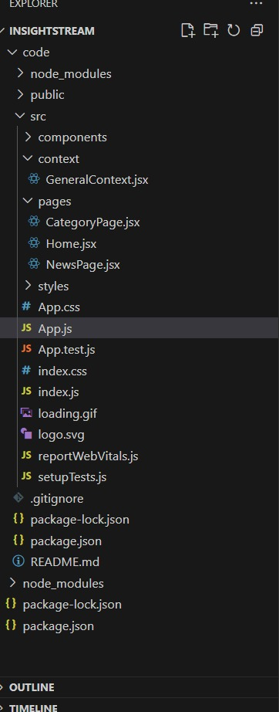

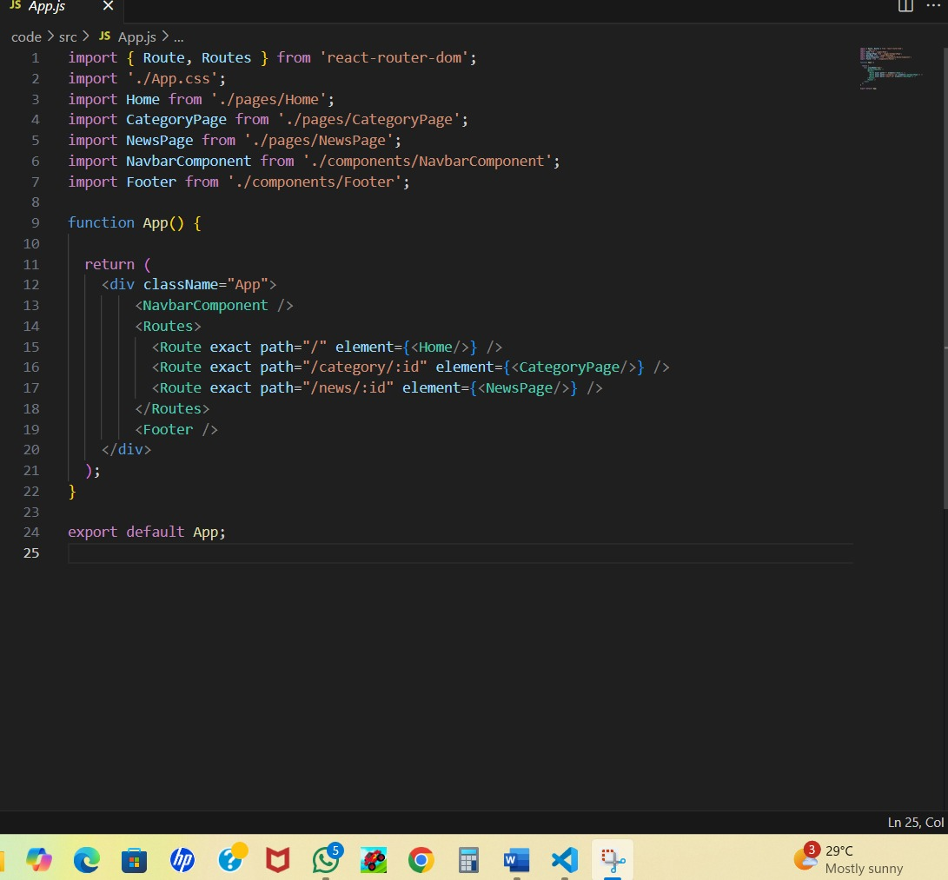

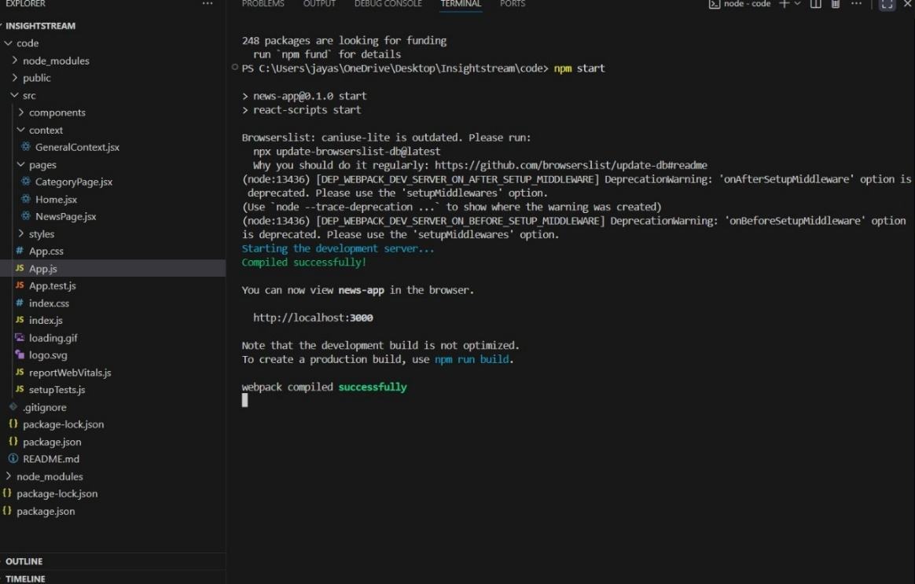

**Conclusion**

The Insight Stream project demonstrates how technology can transform the way people consume news and information. By integrating React, HTML, CSS, and JavaScript, it delivers a responsive, fast, and user-friendly platform where users can explore categorized news with ease.

Through proper testing and optimization, the project ensures reliability, accessibility, and real-time insights. It highlights the importance of digital solutions in keeping users informed, engaged, and connected to the world.

Overall, Insight Stream is not just a news application but a step toward smarter, organized, and interactive information sharing in today’s digital era.